006CPJ744 - shrinivash

Task 1 : what is a big – O notation :
- it’s a way to represent the worst case complexity of an algorithm
examples include :
- o(n)
- o(1)
- o(logn)
- o(nlogn)
- o(n^2)

Task 2 : what are arrays , types of arrays :
Arrays : i
- indexed linear DS to store elements
Types :
- 1d
- 2d
- 3d

Task 3 : String in java

- Sequence of characters
- Can also be said as character arrays

Task 4:

Create an array in java

Task 5:

Create a java pogram to print the String in reverse order.
11.51 to 11.54

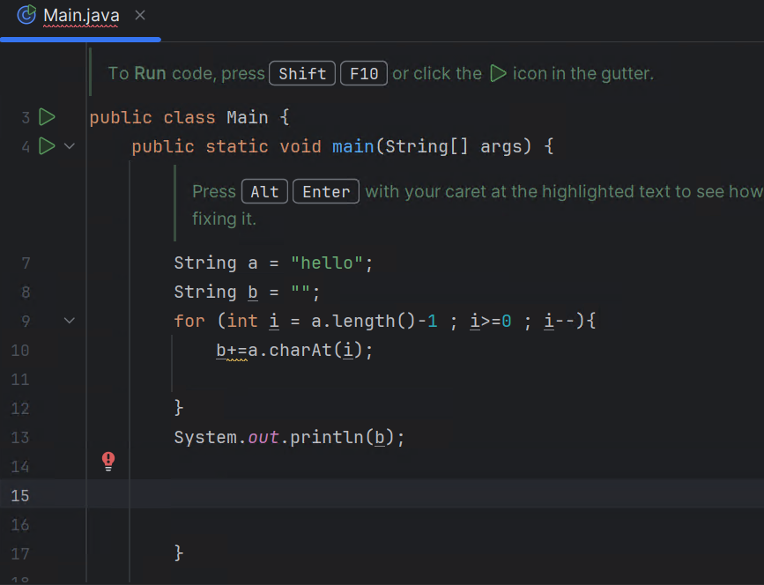

Task 6:

Wap to declare static and normal variables and increment the values of both.. What do you observe?
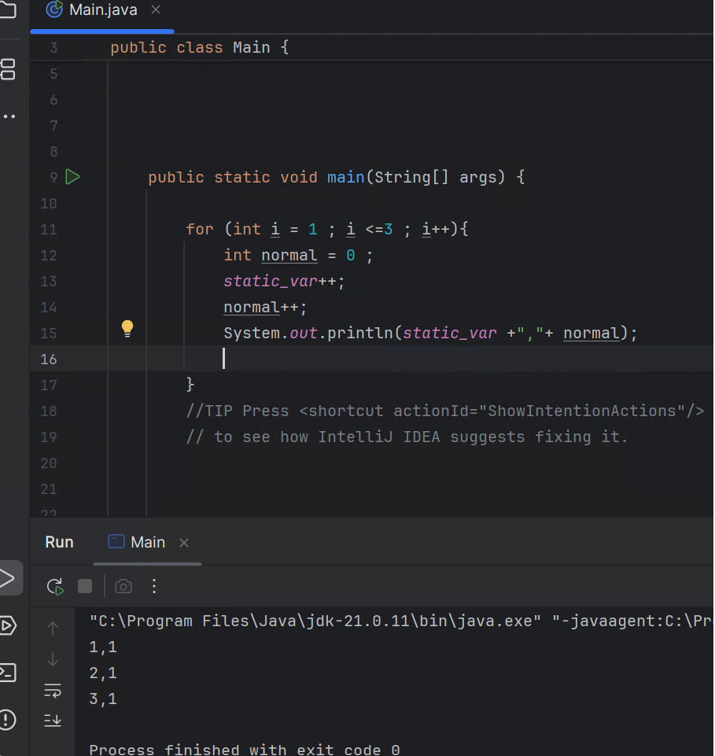

Task 7:

Wap to print numbers from 100 to 10
12.01 to 12.05
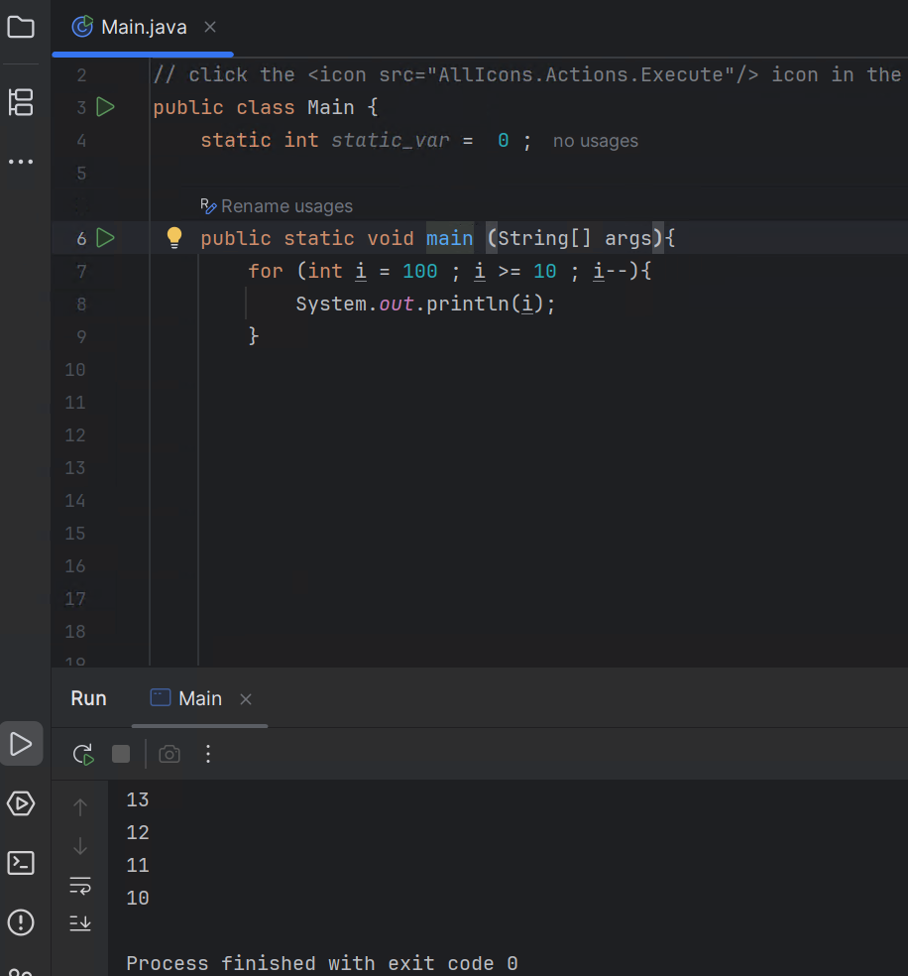

Task 8:

Wap to accept logon id and pwd from the user and display welcome message if
Login id is “Prasunamba” pwd is “4321”
Use while loop …
//TIP To <b>Run</b> code, press <shortcut actionId="Run"/> or
// click the <icon src="AllIcons.Actions.Execute"/> icon in the gutter.
import java.util.Objects;
import java.util.Scanner;
public class Main {
static int static_var = 0 ;
public static void main (String[] args){
Scanner sc = new Scanner((System.in));
String u_name_crct = "Prasunamba";
String pass_crct = "4321";
String u_name , pass = " ";
int key = 0 ;
while(key !=1){
System.out.println("enter uname");
u_name = sc.nextLine();
System.out.println("enter pass");
pass = sc.nextLine();
System.out.println(u_name + pass);
if (u_name.equals(u_name_crct) && pass.equals(pass_crct)){
System.out.println("logged in ");
key = 1 ;
}
else{
System.out.println("try again ");
}
}
}
}

12.06 to 12.10

Task 9:

Wap to accept login id and pwd from the user and display welcome message and then check for the login id and pwd ..
Use do while loop..

//TIP To <b>Run</b> code, press <shortcut actionId="Run"/> or
// click the <icon src="AllIcons.Actions.Execute"/> icon in the gutter.
import java.util.Objects;
import java.util.Scanner;
public class Main {
static int static_var = 0 ;
public static void main (String[] args) {
Scanner sc = new Scanner((System.in));
String u_name_crct = "Prasunamba";
String pass_crct = "4321";
String u_name, pass = " ";
int key = 0;
do {
System.out.println("enter uname");
u_name = sc.nextLine();
System.out.println("enter pass");
pass = sc.nextLine();
System.out.println(u_name + pass);
if (u_name.equals(u_name_crct) && pass.equals(pass_crct)) {
System.out.println("logged in ");
key = 1;
} else {
System.out.println("try again ");
}}
while (key != 1) ;
}
}

12.11 to 12.15

Task 10:

Wap to display the use of
If
Else if
Nested if

//TIP To <b>Run</b> code, press <shortcut actionId="Run"/> or
// click the <icon src="AllIcons.Actions.Execute"/> icon in the gutter.
import java.util.Objects;
import java.util.Scanner;
public class Main {
static int static_var = 0 ;
public static void main (String[] args) {
Scanner sc = new Scanner(System.in);
int num = sc.nextInt();
if (num %2==0){
System.out.println("even");
}
else if(num == 1){
System.out.println("number is 1");
}
else{
System.out.println("odd");
}
}
}

12.16 to12.28

Task 11:

Wap to display the use of switch case
12.29 to 12.34

//TIP To <b>Run</b> code, press <shortcut actionId="Run"/> or
// click the <icon src="AllIcons.Actions.Execute"/> icon in the gutter.
import java.util.Objects;
import java.util.Scanner;
public class Main {
static int static_var = 0 ;
public static void main (String[] args) {
Scanner sc = new Scanner(System.in);
int choice = sc.nextInt();
switch(choice){
case 1:
System.out.println("1");
case 2 :
System.out.println("2");
}
}
}

Task 12:

What are access modifiers in java … give detailed explanation?

- Used to define the level of access a java method or member variable can have

4 types

- Public – anyone can access

- Protected – any member of the package can access

- Private – only members of the class can access the member

- Default - same as protected ; any member of the package can access

12.35 to 12.40

Task 13:
Wap to accept cust names and display them using for each loop
12.47 to 12.50

//TIP To <b>Run</b> code, press <shortcut actionId="Run"/> or
// click the <icon src="AllIcons.Actions.Execute"/> icon in the gutter.
import java.util.Objects;
import java.util.Scanner;
public class Main {
static int static_var = 0 ;
public static void main (String[] args) {
Scanner sc = new Scanner(System.in);
String[] names = {"hay","bou"};
for (String name :names){
System.out.println(name);
}
}
}

Task 14:
Wap to show the difference between break and continue.
Use for loop to show the diff
2.05 to 2.10

With Break :
import java.util.Objects;
import java.util.Scanner;
public class Main {
static int static_var = 0 ;
public static void main (String[] args) {
for (int i = 0 ; i < 100 ; i++){
if (i==10){
break ;
}
else {
System.out.println(i);
}
}
}
}

without break :
import java.util.Objects;
import java.util.Scanner;
public class Main {
static int static_var = 0 ;
public static void main (String[] args) {
for (int i = 0 ; i < 100 ; i++){
if (i==10){
}
else {
System.out.println(i);
}
}
}
}

